Unlike previous assignments, I had a little bit of problem with this project. I spent quite a few days on it but got nowhere. I created an OOP based nodelink project that can be updated on every single dataset, which is uploaded to the canvas. First things first, I created a Node class with all of the functionalities of a node.

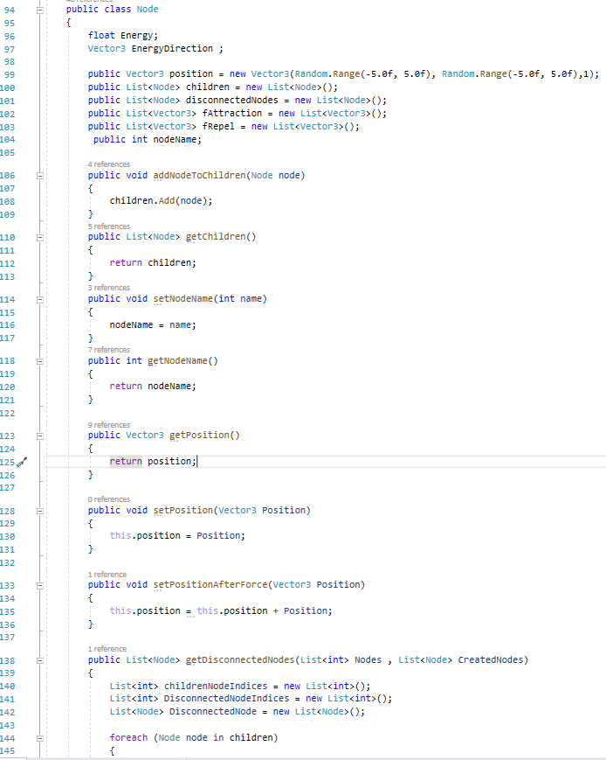

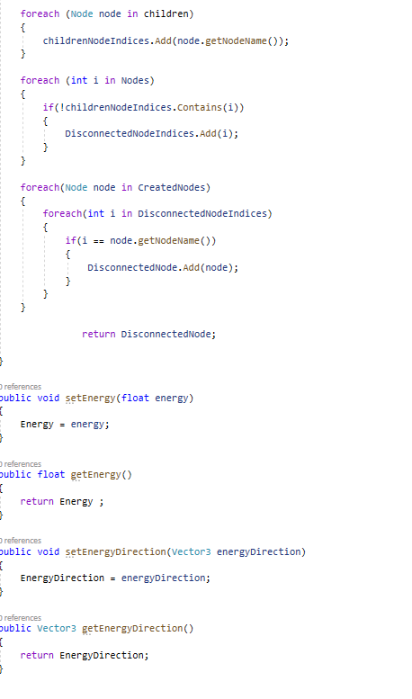

After reading the data, I keep track of every single created Node and its corresponding index.

Then, I create the base graph using some random positions with this method:

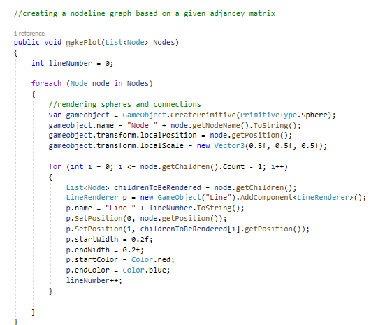

After this and applying the appliedForceGraph method, I try to modify the location in each frame by using this method in Update() function. However, it seems that the model does not converge and it gets bigger and bigger until it comes infinity. I tried to limit the number of iterations and the magnitude of the update to a certain limit to get things moving though.

